**Website feedback**

**Risk Details**

1. Ensure controls library or customer controls and treatment plans can all be linked to a risk. (pending)

**Controls**

1. Show the library of controls I sent on excel (pending)
2. There is level 1 category controls and subcategory of controls

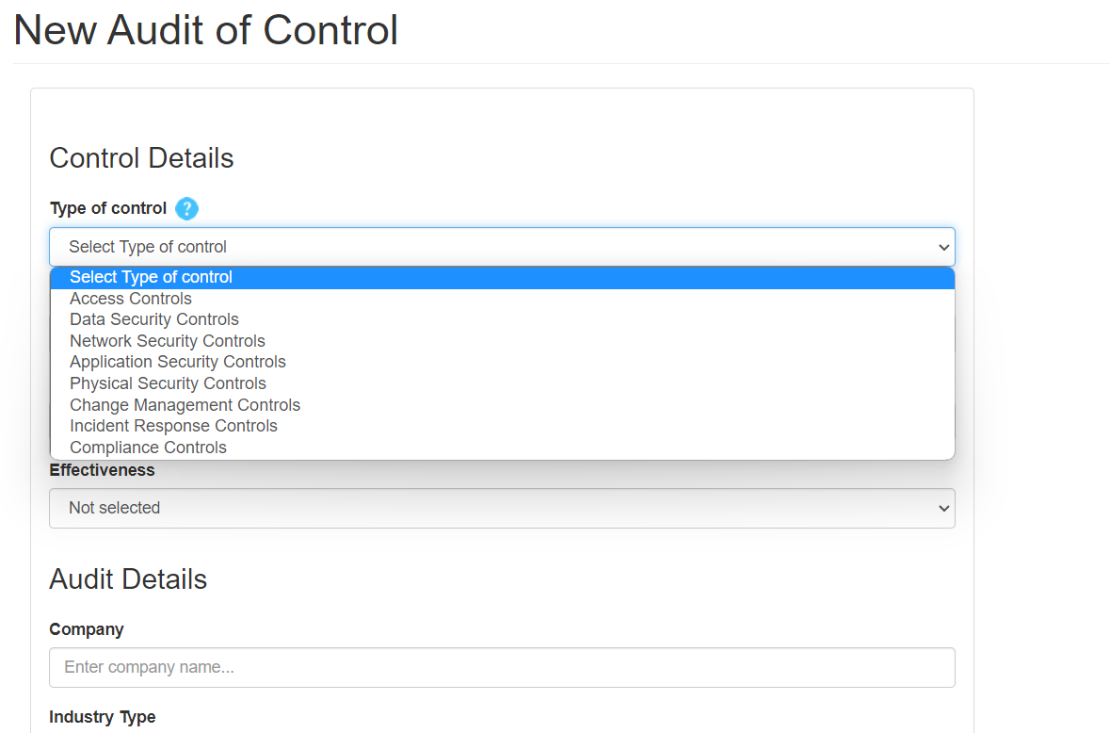

1. Received an error when doing a test of control (not found for me error)



1. Test of controls section has a ‘Treatment’ answer. This treatment created must be added to the overall Treatments and have the ability to link to a risk or compliance standard.
2. Next test date in test of controls section doesn’t work.
3. Free form boxes in Test Procedure is too small. Need to make the length longer

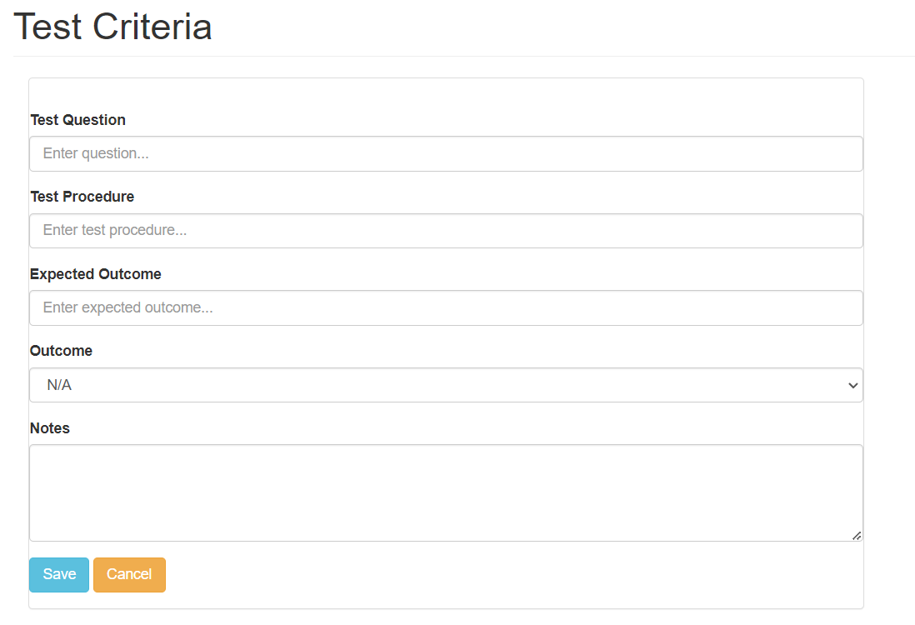

**Dashboards**

1. Can use colours better
   1. Effective controls pie chart can be green
   2. Ineffective controls pie chart can be red
   3. Change title of ‘Not Selected’ to ‘Not Tested’ and have this pie chart in amber
   4. Open Incidents and In progress incidents should be the same right? Instead the third pie chart for Incidents could be ‘Overdue Incidents’
      1. Closed Incidents in Green
      2. In Progress Incidents in Amber
      3. Overdue Incidents in Red
   5. Same with Treatments
      1. Closed Treatments in Green
      2. In Progress Treatments in Amber
      3. Overdue Treatments in Red
   6. Risk graph – why do we need the red horizontal graph? You can show a summary of per below on all risks by bar graph :
      1. Extreme risks,
      2. High risks,
      3. Medium risks,
      4. Low risks
   7. It would also be good to show a graph next to risk graph showing type of actions taken for the risk in one pie chart

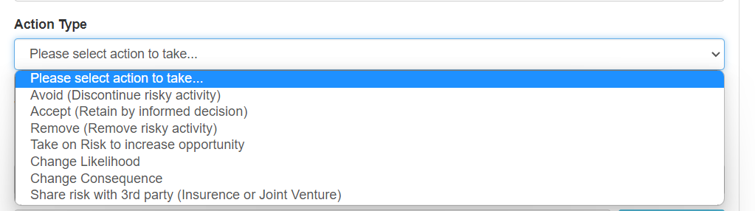

* 1. Show a pie chart section on compliance below risk section
     1. Number of effective compliance standards (green)
     2. Number of ineffective compliance standards (red)
     3. Number of overdue Policy Reviews (Amber)

**Reports**

1. None of the excel reports were able to be extracted and got an error message
2. We should show the compliance standard and policy report extract option here aswell.

**Emails**

1. Create [Jay@risksafe.co](mailto:Jay@risksafe.co)
2. Send messages from the website to the email above

**Notifications**

Send notification email to Process Owner and Assessor

1. When a new risk is created
2. When a risk is closed
3. When an Incident is created
4. When a control test has been completed
5. When treatment plan is due
6. When a control test is due
7. When a policy review is due
8. When a compliance standard is created

**Users – should be completed**

1. Have the ability to create 1 admin for a customer and for them to create multiple users/profiles . can have up to 20 additional user profiles.
2. The admin can have restricted access
3. Profile types can have access types: Admin, user, read only
4. When a new user is created by a super user, can the new user automatically login with the new login details of the new user?

**My payments**

1. We should make it so they can signup and login for free then after 14 days then need to pay $49 a month .  I have stripe so can use that - have you linked stripe?

An example below

1. To extract either the risk assessment or audit of controls, I’m thinking of getting the customer to pay a fee after 14 days.  That would mean including their credit card details through stripe and then unlocking the option to extract the information they had input as a PDF, CSV or Word file.
2. Customer credit card is charged and invoice is sent to his/her email address.

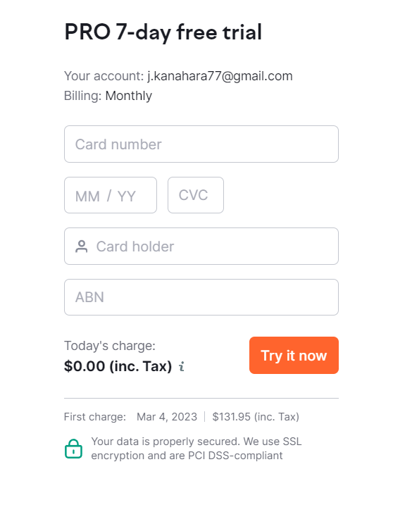

**RiskSafe Admin panel** – should be completed

1. Admin login (me)
2. Have ability to see all profiles and profile information

Upload feature – To consider

1. Have a template to do a bulk upload where we provide a template to a new customer and we give them the correct rows, columns and tables for us to then create bulk entries (some customer will not be starting new, they will have existing controls, risks, incidents)